ZTT Compliance Rules on Compliance Audit
- General Provisions
- Pursuant to the relevant laws, rules, and regulations of China and other countries in which the Jiangsu Zhongtian Technology Co., Ltd. (the “Company” or “ZTT”) operates (collectively “Applicable Laws”) and the Compliance Guidelines, the Employees’ Compliance Code of Conduct and other compliance policies and requirements of the Company (“ZTT Compliance Policies”), taking into account the business environments in which the Company operates, these Rules are formulated to better promote the full set compliance administrative measures, to facilitate the Company’s legitimate and compliant business operation with integrity, and to prevent and reduce Compliance Risks.
- These Rules apply to the business activities carried out by Company and its foreign and domestic controlled subsidiaries (hereinafter referred to as the “Subsidiaries”). The Compliance Standard Department of the Company will supervise over the implementation of these Rules by its Subsidiaries.
- Terms in these Rules are defined as follows:
- “Compliance” means the business operations of the Company and its Subsidiaries conform to the requirements of applicable laws, international conventions, Compliance Codes of International Organization, regulatory provisions, industrial standard, business practice, ethics and the Company’s articles of association and rules and regulations.
- “Compliance Risks” refers to the possibility that legal sanction, administrative penalty, significant loss of property or reputation occurs to the Company and its Subsidiaries or Employees due to Noncompliance Conducts.
- “Appropriate Compliance Department”, depending on the entities responsible for the business operations, refers to Compliance Standard Department of the Company; or Compliance Department or Compliance Officers of the Subsidiaries.
- “Business Department” refers to department or organization under the Company or the Subsidiaries responsible for business operation and signing contracts, including but not limited to Business Divisions and Purchase & Supply Divisions of the Company and Market Department of Subsidiaries.
- “Internal Audit” refers to the compliance audit conducted by the Appropriate Compliance Department of the Company and its Subsidiaries toward the various departments/divisions within the unit on the implementation and effectiveness of the Compliance Rules of ZTT. For instance, the compliance audit of Purchase & Supply Division of the Company conducted by the compliance audit team formed by the Company’s Compliance Standard Department is one kind of such Internal Audit.
- “Cross-audit” refers to the compliance audit conducted by the appropriate compliance department of the Company and the Subsidiaries toward other subsidiary on the implementation and effectiveness of the Compliance rules of ZTT. The compliance audit of ZTT International Limited conducted by the compliance audit team formed by the Company’s Compliance Standard Department is an example of such Cross-audit.
- The Company and the Subsidiaries shall make annual compliance audit plan each year, and shall organize compliance audit groups to conduct Internal Audit, as well as Cross-audit, ensuring that at least one round compliance audit on the Company and each Subsidiary will be carried out every three years. In addition to the above regular audits, the Appropriate Compliance Department of the Company or any Subsidiary may, upon the creditable report from employees or others reports substantiating material compliance risk of certain Subsidiaries or certain Business Department of a specific Subsidiaries, conduct extra compliance audit as needed.

- Compliance Audit Procedure
- The Appropriate Compliance Department of each Subsidiaries shall make its annual compliance audit plan based on actual situation of its business, and submit the plan to the Compliance Standard Department of the Company. The annual compliance audit plan of the Company shall be prepared by the Compliance Officers of the Company and submitted to the Compliance Standard Department of the Company. The Compliance Standard Department of the Company will, taking into account all submitted plans and holistic development of the business of the Company and the Subsidiaries, determine the annual Internal Audit and Cross-audit plans of the Company and the Subsidiaries and submit the same to Compliance Committee of the Company for record. (See Annex 1 – Compliance Audit Procedure Chart)
- The Appropriate Compliance Department of the Company and the Subsidiaries shall select Compliance Officers at all levels or personnel from related Business Departments to form a compliance audit group (with 1 group leader and at least 2 members in addition) which shall conduct Internal Audit and Cross-audit over the Company, the Subsidiaries and all Business Departments. The Compliance Audit could be concurrently processed with internal financial auditing plans of the Company.
The Appropriate Compliance Department of each Subsidiaries is responsible to organize and perform compliance audit. The Compliance Officers of the audited entities or Business Departments shall actively cooperate with the compliance audit group. In case there is no Compliance Officer in an audited Business Department, the business personnel of such audited Business Department shall actively cooperate with the compliance audit group.
- Compliance audit shall be an on-site or off-site audit, with such two working modes carried out on an individual or combined basis, adhering to the principles of independence, objectivity, impartiality, and efficiency, in which on-site audit will focus on the interview and inspection of internal control systems including compliance management system, implementation of compliance rules, and financial control (see Annex 2 - Compliance Interview Information Form and Annex 3 - Compliance Interview Content Form). In on-site audit, control measures on Compliance Risks of the Audited Company or Business Department will be verified and assessed by retrieving and reviewing business files and relevant documentations and information, and requesting various materials from the audited entities or Business Departments.
During the audit over the training and performance of Compliance Officers, the audited Compliance Officers shall not be present during the audit as per related provisions (see Annex 4 - Compliance Audit Evaluation Form).
- After the completion of compliance audit, the group shall prepare, in light of the audit goals, a written Compliance Audit Report and a written Compliance Audit Rectification Notice, which shall include problems and flaws discovered during the audit and corresponding solution opinions, improvement direction and primary measures. The written Compliance Audit Report shall include a Compliance Audit Solution Opinion Form (see Annex 5), in which:
- The Compliance Audit Solution Opinion Form for the Internal Audit of the Company shall be submitted by the Compliance Officer of the Company to the Chief Compliance Officer of the Compliance Standard Department of the Company for his/her signature;
- The Compliance Audit Solution Opinion Form for the Internal Audit of an Subsidiaries shall be submitted by the Compliance Officer of such Subsidiaries to the head of the Compliance Management Leading Group of the Company for his/her signature;
- The Compliance Audit Solution Opinion Form for Cross-audits shall be submitted by the Compliance Officer of the Company to the Chief Compliance Officer of the Compliance Standard Department of the Company for his/her signature.
For issues spotted in the compliance audit, an internal investigation shall be conducted in accordance with the relevant provisions of the ZTT Compliance Rules on Internal Investigation. All the illegal and undisciplined issues spotted in the audit shall be submitted to the supervision department of the Company and the relevant Subsidiaries for investigation and punishment. All the compliance administration issues spotted in the audit shall be submitted to the Compliance Standard Department and Compliance Committee of the Company.
- The Audited Company or Business Department shall rectify its operation term by term according to the Compliance Audit Report and Compliance Audit Rectification Notice issued by compliance audit group, and shall submit the corresponding rectification report to the Appropriate Compliance Department of the relevant company within 90 days after the execution of the Compliance Audit Report.
- To ensure the actual implementation of rectification measures, the Appropriate Compliance Department of the Company and the relevant Subsidiaries should sustain a continuing follow-up and supervision over the rectification of audited entities and departments.
- The Appropriate Compliance Department of the Company and the relevant Subsidiaries shall, taking into account feedbacks and advices received during compliance audit as well as the situation of business, summarize its practical experiences and periodically analyze the suitableness and effectiveness of the compliance rules, and further revise or supplement compliance policies if necessary (see Annex 6 – Form of Rectification Progress of Compliance Issues).
- Record and File Management of Compliance Audit
- The Appropriate Compliance Department of the Company and the Subsidiaries must properly keep all records, audit reports, and documents during the compliance audit, and duly retain the same pursuant to document retention policy of the Company and the Subsidiaries.
- Punishment and Questions
- Any questions regarding these Rules may be raised to the Appropriate Compliance Department of the Company and the Subsidiaries.

Annexes:
- Compliance Audit Procedure Chart
- Compliance Interview Information Form
- Compliance Interview Content Form
- Compliance Audit Evaluation Form
- Compliance Audit Solution Opinion Form
- Form of Rectification Progress of Compliance Issues

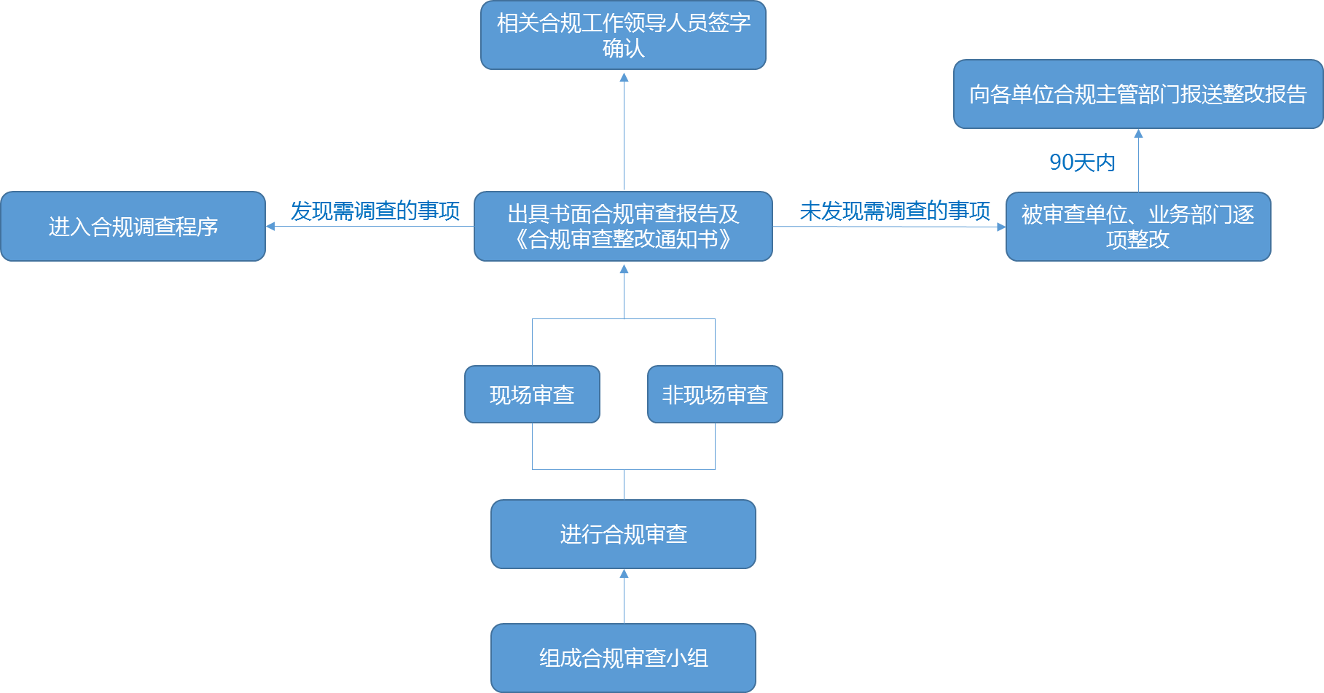
Annex 1 Compliance Audit Procedure Chart
12
11
10
9
8
7
6
5
4
3
2
1

1 forming compliance audit group
2 carrying out compliance audit
3 on-site audit
4 off-site audit
5 issuing written Compliance Audit Report and Compliance Audit Rectification Notice
6 matters requiring investigation found
7 entering into compliance investigation procedure
8 no matters requiring investigation found
9 audited Company or Business Department to make rectification one issue by another
10 within 90 days
11 submitting rectification report to the Appropriate Compliance Department
12 signed by relevant managerial personnel in charge of compliance for confirmation

Annex 2
Compliance Interview Information Form
Interview Information Form
Interviewing Matters:
Members of the Compliance Audit Group:
Audited Company or Business Department:
Interviewee 1: | Time:
Interviewee 2: | Time:
Interviewee 3: | Time:
Interviewee 4: | Time:
Interviewee 5: | Time:
Interviewee 6: | Time:
Interviewee 7: | Time:

Annex 3
Compliance Interview Content Form
Interview Content Form
Interviewing Matters:
Members of the Compliance Audit Group: | Interviewee:
Time: | Audited Company or Business Department:
Signature of the Interviewer:
Signature of the Interviewee:

Annex 4: Compliance Audit Evaluation Form
Audited Company or Business Department:
Date of Compliance Audit:
Head of Compliance Audit Group:
Members of Compliance Audit Group:
Subjects |  | Issues |  |  | Results | Any exceptions? If so, please briefly describe |  |  | Recommended rectifications | Notes
Whether a Compliance Management Organization and personnel is in place and performing duties |  | 1.1 Is there a Compliance Management Organization?
 |  | 1.2 Are the duties of personnel in the Appropriate Compliance Department clear and definite?
 |  | 1.3 Are there full-time Compliance Officers? How many?
 |  | 1.4 Are there any part-time compliance staff members? How many?
 |  | 1.5 Description of publicity and implementation of compliance requirements by full-time Compliance Officers and part-time compliance staff members and records related thereto
 |  | 1.6 Description of compliance training for full-time Compliance Officers and part-time compliance staff members and records related thereto
 |  | 1.7 Compliance coverage by full-time Compliance Officers and part-time compliance staff members and local staff's understanding of compliance work
 |  | 1.8 Have employees signed employee compliance statements and been imposed of high-risk job background surveys?
Implementation of Compliance Policies |  | 2.1 When will the compliance work start?
 |  | 2.2 Are the implementation steps of the compliance work procedure completed?
 |  | 2.3 Is the compliance approval process completed?
 |  | 2.4 Are the financial approval procedures of the compliance work process completed?
 |  | 2.5 Are the records and files for compliance work process completed?
 |  | 2.6 Is the standing book entry for compliance work process completed?
 |  | 2.7 Is the statistical report of compliance work process (monthly report, annual report, etc.) completed?
 |  | 2.8 Is the compliance supervision for the compliance work process completed?
 |  | 2.9 Are the answers and records of internal consultation completed?
Response to Compliance Risk Assessment |  | 3.1 Are compliance risk assessments conducted regularly?
 |  | 3.2 Are effective measures taken against the results of compliance risk assessment?
 |  | 3.3 What measures are taken to deal with different types of risks?
 |  | 3.4 Are internal violations investigated?
 |  | 3.5 Investigation Report and Result Report on Internal Violations
 |  | 3.6 What measures are taken to deal with internal reporting?
Compliance Training, Publicity and Implementation |  | 4.1 Is the annual compliance training plan in accordance with the requirements of the higher authorities?
 |  | 4.2 Are the training tasks given by the higher authorities and the management of the unit completed on time?
 |  | 4.3 Is the compliance training record complete?
 |  | 4.4 Does compliance training achieve the desired results?
 |  | 4.5 Priority given by major management members to compliance policy implementation and relevant implementation records
 |  | 4.6 Description and effect of compliance publicity and implementation towards partners and third parties
Assessment of Compliance Work |  | 5.1 Annual Assessment of Compliance Work
 |  | 5.2 Is annual compliance assessment conducted on employees? What is the result?
Signature of Handling Person for Compliance Audit:
Signature of Person in Charge of Audited Unit or Business Department:
Signature of the Compliance Officer of the Audited Unit:

Annex 5: Compliance Audit Solution Opinion Form
Audited Company or Business Department:
Date of Compliance Audit:
Head of Compliance Audit Group:
Members of Compliance Audit Group:
Case Number | Violations Details |  | Accountable Person |  | Consequences/Results |  | Applicable Rules for Determination of Nature of Violations |  | Evidence and Assessment Records (please specify if there is any attachment) |  | Solution Opinions |  | Remedy and Rectification Measures
Signature of Handling Person for Compliance Audit:
Signature of Leader of Compliance Management Leading Group/Chief Compliance Officer:

Annex 6: Form of Rectification Progress of Compliance Issues

Problems Spotted | Causes | Suggestions for Adjustment and Improvement | Reasons for Adjustment | Suggested Improvement Measures | Timeline for Improvement
 |  |  |  | Signature of Compliance Officer
 |  |  |  | Name:
 |  |  |  | Date:

