ZTT Compliance Rules on Cash Payment

- General Provisions
- In order to mitigate compliance risk when utilizing cash payments for operating activities, Jiangsu Zhongtian Technology Co., Ltd. (hereinafter referred to as the “Company”) formulated this Compliance Rules in accordance with relevant Chinese laws, rules, and regulations as well as laws, rules, and regulations of countries in which the Company operates (collectively “applicable laws”) and ZTT Compliance Guidelines, and in consideration of the environments in which the Company operates.
- The Rules apply to the operation activities of the Company and its foreign and domestic controlled subsidiaries (hereinafter referred to as “Subsidiaries”).
- The Rules apply to all Employees of the Company and its Subsidiaries.
- Key terms used herein are defined as follows:
- “Compliance” means the adherence to the requirements of applicable laws, international conventions, Compliance Codes of International Organization, regulatory provisions, industrial standards, business practice, ethics and the Company’s articles of association and rules and regulations by the Company and Subsidiaries in their regular course of business.
- “Appropriate Compliance Department”, depending on the entities responsible for the business operations, refers to the Compliance Standard Department of the Company; or the Compliance Department or Compliance Officer(s) of the Subsidiaries.
- “Cash Payment” refers to any payment made in cash or cash equivalent, including anonymous, non-traceable check or money order.

- Principles for Use of Cash Payments
- The Company and Subsidiaries explicitly prohibit the establishment or use of off-the-book accounts or payments.
- Whenever possible, it is the policy of the Company and Subsidiaries to avoid Cash Payments. However, the Company and Subsidiaries conduct business in many countries with unreliable banking sectors and local financial institutions, and thus conducting business in such countries may require utilizing Cash Payments in the course of the Company and Subsidiaries’ business, including for the purchase of local project equipment and materials, office supplies, and payment of wages to local employees. Nevertheless, any facilitation payments are prohibited (i.e. any Cash Payment to a government officer in order to accelerate process of the regular administrative duties without discretion). While not prohibited per se, Cash Payments present high compliance-related risk and the Company and Subsidiaries must take precautions before engaging in Cash Payments.
- The Company and Subsidiaries shall have detailed financial controls for authorizing and documenting Cash Payments. These financial controls shall, at the least:
1. The cashier shall only make the Cash Payment upon the approval by the supervisor of business unit, supervisor of financial unit, and general manager or other authorized person for the report signed and submitted by the direct responsible person;
2. Maintain contemporaneous written documentation of each Cash Payment made;
3. Establish and improve cash accounting system, where each cash payment and balance shall be recorded;
4. Arrange Employees other than cashier, to inspect the cash reserves at least monthly regarding the conformity between cash reserves and accounts, filling inspection record, and to report to supervisor of financial unit when discovering problems.
- In addition to those rules and controls, the Rules on Cash Payment set out the ethical and compliance-related principles that should guide all Cash Payments. The following key principles apply to all Cash Payments:
1. All Cash Payments must comply with the ZTT Compliance Guidelines, ZTT Compliance Rules on Gifts and Hospitality, ZTT Compliance Rules on Donations and Sponsorship, and ZTT Compliance Rules for Due Diligence on Third Party.
2. Cash Payments may only be made when absolutely necessary due to the limitations of the relevant banking sector. Employees must explain why a Cash Payment was necessary for any particular payment.
3. Cash Payments must be fully documented with complete supporting documents identifying the recipient of the payment, such as an invoice, receipt or internal purchase order, proof of the goods or services being purchased or the salaries being paid, or other internal supporting documentation. As a general rule, Employees may not make a Cash Payment without obtaining such documentation (see Article 8 and Annex 1 Cash Payment Management Chart for more information).
4. Given the particular concerns in this area, the Company will have zero tolerance for inappropriate use of Cash Payments. When making a Cash Payment, Employees must use caution to ensure that all relevant policies and rules are being carefully followed. Any Employee found to have made a Cash Payment in a manner that is inconsistent with the principles described herein will be appropriately disciplined
- In very limited situations, a receipt, invoice or internal purchase order or other internal supporting documents may not be available. In such circumstances, the Employee is permitted to make a Cash Payment only if the following conditions are met:
1. The amount does not exceed ¥500 equivalent;
2. The Cash Payment is immediately (within one business day) reported to the local appropriate compliance officer using the Cash Payment Reporting Form (Annex 2). The Employee making the payment must document the amount of the payment, the recipient, and the reason that a receipt, invoice or internal purchase order or other internal supporting documents was not obtained.
It will be the responsibility of the Compliance Standard Department of the Company to record payments made that were not documented with a receipt or invoice using the Cash Payment Log (Annex 3), and Appropriate Compliance Department shall report to the Compliance Standard Department of the Company on a monthly basis regarding payments made that were not documented with a receipt or invoice using the Cash Payment Log (Annex 3).

- COMPLIANCE RECORDS AND DOCUMENTS MANAGEMENT
- Sufficient supporting documents should support each Cash Payment to ensure the payment is truthful, legitimate, and reasonable and the transaction amount is accurate. The appropriate cashier should record each transaction in the daily cash or bank deposit journal after completion of the Cash Payment and should maintain the supporting documentation in accordance with the Company or Subsidiaries’ document retention policies.
- The Appropriate Compliance Department has the authority to audit the financial controls surrounding Cash Payments periodically as it considers necessary or prudent. Auditing includes steps to determine whether Cash Payments are utilized only when necessary, are properly recorded, documented and accompanied with supporting documents, and comply with the ZTT Compliance Guidelines, ZTT Compliance Rules on Gifts and Hospitality, ZTT Compliance Rules on Donations and Sponsorship, and ZTT Compliance Rules on Third Party Due Diligence.
- The Appropriate Compliance Department, in coordination with internal and external audit where necessary, must prepare a plan periodically and must utilize a risk-based approach to determine the location and frequency of the audits to ensure that the Rules and regulations, the management process and implementation effect regarding Cash Payment in the Company or Subsidiaries comply with the applied laws and compliance polices.
- Each audit will be accompanied by a report detailing any failures observed. Such reports will be maintained by the Appropriate Compliance Department and shared with the Compliance Standard Department of the Company upon its request.

- DISCIPLINE
- Failure to comply with the Rules will be grounds for disciplinary action, up to and including termination of employment, consistent with the Company’s disciplinary process and any applicable laws.

- SUPPLEMENTARY PROVISIONS
- Any questions concerning the Rules should be addressed to the appropriate compliance department.
- The Compliance Standard Department, on behalf of the Company, exercises the supervision on the implementation of this Rules in its departments, and it has the ultimate right to instruct and interpret the implementation of this Rules.

ANNEXES
Annex 1: Cash Payment Management Chart
Annex 2: Cash Payment Reporting Form
Annex 3: Cash Payment Log
Annex 1: Cash Payment Management Chart
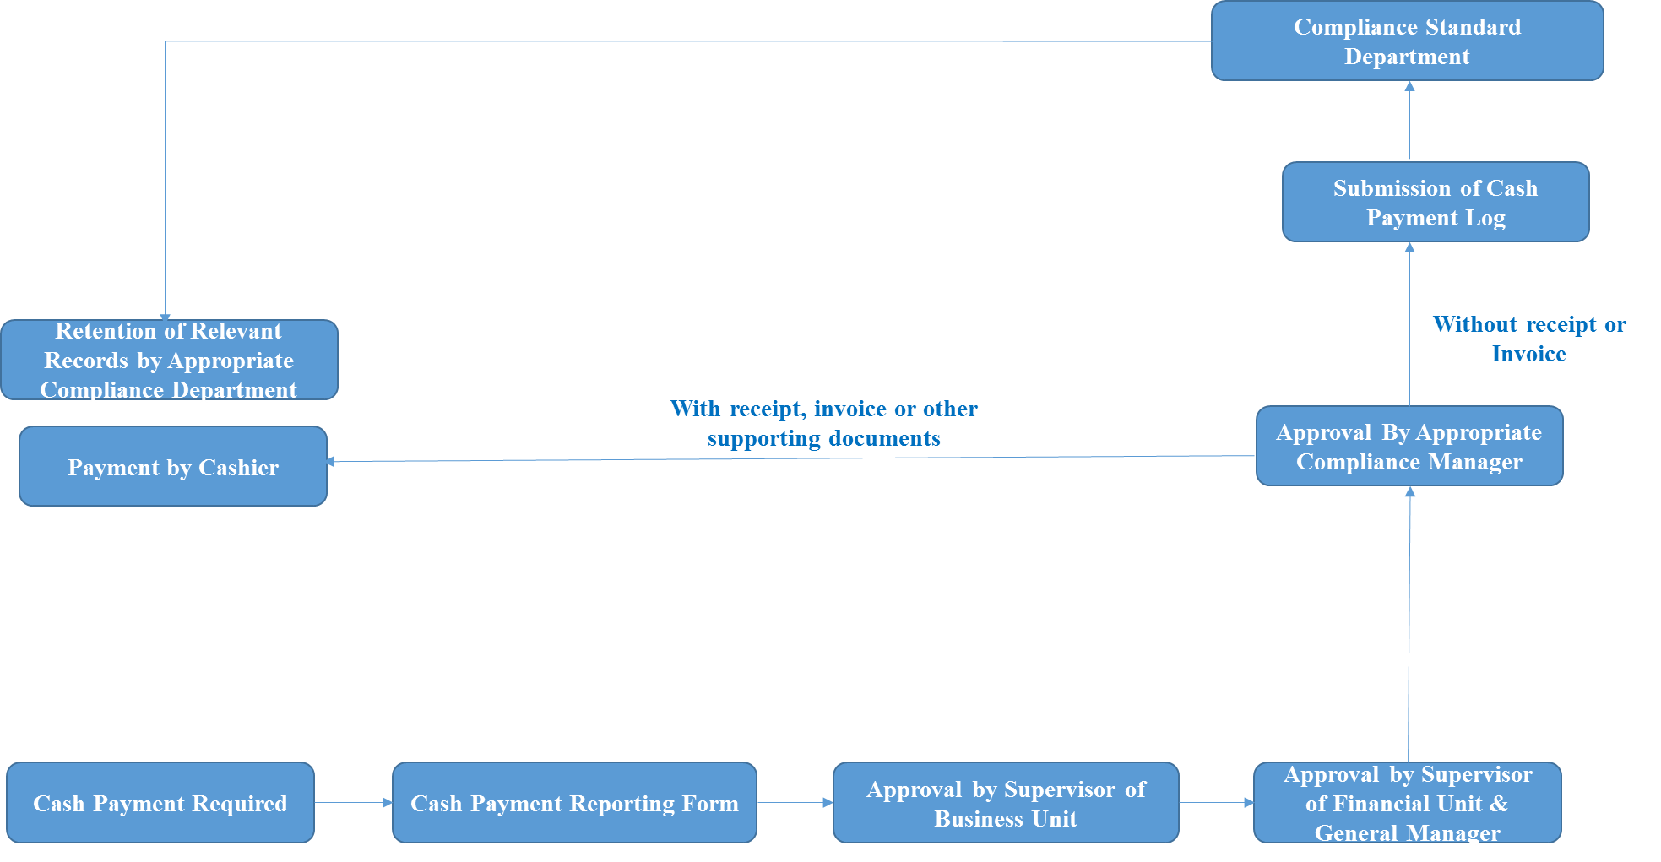

Annex 2: Cash Payment Reporting Form

Reporting Employee
Employee Position
Company & Department
Date of Report

Recipient of Payment
Services or goods provided (or salary paid if applicable) and uses
Reasons for Cash Payment
Currency
Amount
Converted to RMB Amount
Explanation for Lack of Supporting Documentation

Reporting Employee:  Position:  Company/Dept.:  Date: | Supervisor of Business Unit:  Supervisor of Financial Unit:  General Manager  Date:  Appropriate Compliance Department:  Date:

Annex 3: Cash Payment Log

Date | Amount | Name of Reporting Employee | Name of Recipient | Reason for Lack of Documentation

